C program to read a file: This program reads a file entered by the user and displays its contents on the screen, fopen function is used to open a file it returns a pointer to structure FILE. FILE is a predefined structure in stdio.h . If the file is successfully opened then fopen returns a pointer to file and if it is unable to open a file then it returns NULL. fgetc function returns a character which is read from the file and fclose function closes the file. Opening a file means we bring file from disk to ram to perform operations on it. The file must be present in the directory in which the executable file of this code sis present.

**C program to open a file**

C programming code to open a file and to print it contents on screen.

#include <stdio.h>

#include <stdlib.h>

int main()

{

char ch, file_name[25];

FILE *fp;

printf("Enter the name of file you wish to see**\n**");

gets(file_name);

fp = fopen(file_name,"r"); *// read mode*

if( fp == NULL )

{

perror("Error while opening the file.**\n**");

exit(EXIT_FAILURE);

}

printf("The contents of %s file are :**\n**", file_name);

while( ( ch = fgetc(fp) ) != EOF )

printf("%c",ch);

fclose(fp);

return 0;

}

Download [Read file](http://www.programmingsimplified.com/executable/c/read-file.exe) program.

Output of program:  
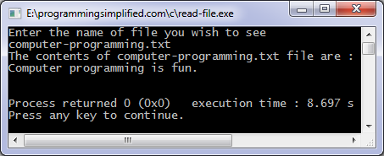

C program to copy files: This program copies a file, firstly you will specify the file to copy and then you will enter the name of target file, You will have to mention the extension of file also. We will open the file that we wish to copy in read mode and target file in write mode.

**C programming code**

#include <stdio.h>

#include <stdlib.h>

int main()

{

char ch, source_file[20], target_file[20];

FILE *source, *target;

printf("Enter name of file to copy**\n**");

gets(source_file);

source = fopen(source_file, "r");

if( source == NULL )

{

printf("Press any key to exit...**\n**");

exit(EXIT_FAILURE);

}

printf("Enter name of target file**\n**");

gets(target_file);

target = fopen(target_file, "w");

if( target == NULL )

{

fclose(source);

printf("Press any key to exit...**\n**");

exit(EXIT_FAILURE);

}

while( ( ch = fgetc(source) ) != EOF )

fputc(ch, target);

printf("File copied successfully.**\n**");

fclose(source);

fclose(target);

return 0;

}

Download [File copy](http://www.programmingsimplified.com/executable/c/copy-file.exe) program.

Output of program:  
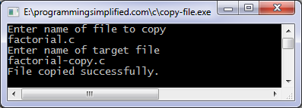

* This c program merges two files and stores their contents in another file. The files which are to be merged are opened in read mode and the file which contains content of both the files is opened in write mode. To merge two files first we open a file and read it character by character and store the read contents in another file then we read the contents of another file and store it in file, we read two files until EOF (end of file) is reached.

## C programming code

* #include <stdio.h>
* #include <stdlib.h>
* int main()
* {
* FILE *fs1, *fs2, *ft;
* char ch, file1[20], file2[20], file3[20];
* printf("Enter name of first file**\n**");
* gets(file1);
* printf("Enter name of second file**\n**");
* gets(file2);
* printf("Enter name of file which will store contents of two files**\n**");
* gets(file3);
* fs1 = fopen(file1,"r");
* fs2 = fopen(file2,"r");
* if( fs1 == NULL || fs2 == NULL )
* {
* perror("Error ");
* printf("Press any key to exit...**\n**");
* getch();
* exit(EXIT_FAILURE);
* }
* ft = fopen(file3,"w");
* if( ft == NULL )
* {
* perror("Error ");
* printf("Press any key to exit...**\n**");
* exit(EXIT_FAILURE);
* }
* while( ( ch = fgetc(fs1) ) != EOF )
* fputc(ch,ft);
* while( ( ch = fgetc(fs2) ) != EOF )
* fputc(ch,ft);
* printf("Two files were merged into %s file successfully.**\n**",file3);
* fclose(fs1);
* fclose(fs2);
* fclose(ft);
* return 0;
* }
* Download [merge files](http://www.programmingsimplified.com/executable/c/merge-files.exe) program.
* Output of program:  
  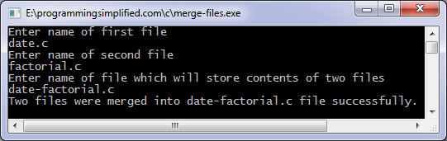

This program list all files present in a directory/folder in which this executable file is present. For example if this executable file is present in C:\\TC\\BIN then it will lists all the files present in C:\\TC\\BIN.

## C programming code(Turbo C compiler only)

#include <stdio.h>

#include <conio.h>

#include <dir.h>

int main()

{

int done;

struct ffblk a;

printf("Press any key to view the files in the current directory**\n**");

getch();

done = findfirst("*.*",&a,0);

while(!done)

{

printf("%s**\n**",a.ff_name);

done = findnext(&a);

}

getch();

return 0;

}

Obviously you will get a different output when you will execute this file on your computer.

This c program deletes a file which is entered by the user, the file to be deleted should be present in the directory in which the executable file of this program is present. Extension of the file should also be entered, remove macro is used to delete the file. If there is an error in deleting the file then an error will be displayed using perror function.

**C programming code**

#include<stdio.h>

main()

{

int status;

char file_name[25];

printf("Enter the name of file you wish to delete**\n**");

gets(file_name);

status = remove(file_name);

if( status == 0 )

printf("%s file deleted successfully.**\n**",file_name);

else

{

printf("Unable to delete the file**\n**");

perror("Error");

}

return 0;

}

Download [Delete file](http://www.programmingsimplified.com/executable/c/delete-file.exe) program executable.

Output of program:  
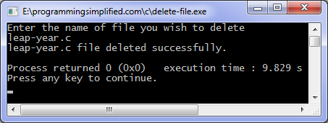

Deleted file doesn't go to trash or recycle bin so you may not be able to recover it. Deleted files can be recovered using special recovery software if the files are not overwritten on the storage medium.